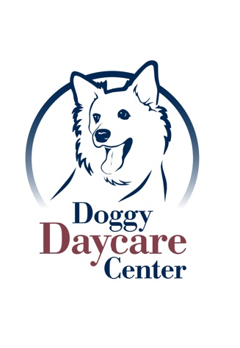
Orrville Pet Spa & Resort
1669 N. Main St. Orrville, Ohio 44667
(330) 683-3335 1-866-406-OPSR

DAYCARE PERSONALITY PROFILE & RELEASE FORM

Owner:________________ Dogs Name:__________________ Date:__________

Is your dog food or treat sensitive or does he/she have food allergies? Please explain. YES NO _________________________________________________________________________________________________________________________________________________________________________________________________________
Do we have your permission to give your dog treats while here? YES NO

Is it common for your dog to have diarrhea? If so please explains what the factors are (ex. Stress, certain foods) _________________________________________________________________________________________________________________________________________________________________________________________________________
If your dog has diarrhea while at daycare, and it continues multiple times, do we have your permission to give *Endosorb? *A one-time fee of $8.50 will be charged when medication is administered.
YES NO
If your dog has vomited while at daycare typically we give a break and if everything was fine we put them back into the group. Would there be any other thing you would like us to do? (ex. Call, give a small amount of food) _________________________________________________________________________________________________________________________________________________________________________________________________________

