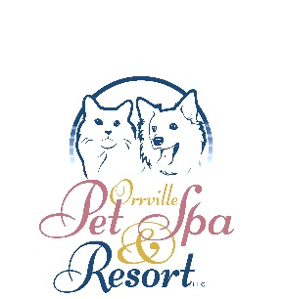
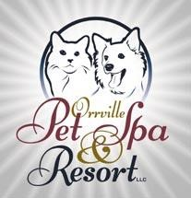

CANCELLATION & NO SHOW POLICY

At The Orrville Pet Spa and Resort, we pride ourselves in providing the highest level of care for your companion. We cannot accomplish this goal without your participation.

Therefore, as a courtesy to others, please report cancellations 24 hours in advance of your scheduled lodging reservation or grooming appointment.

Clients who schedule and do not keep their reservation, without canceling, interfere with our facility schedule. This takes up valuable space that could have been used by other clients.

The groomers are paid based on a full schedule. If a late cancellation occurs, it is too late to fill the schedule, thus they lose pay.

Effective January 1, 2018 our policy regarding cancellations/no shows is as follows:

For lodging: The cost of one night’s stay, in the room reserved, will be applied to your account if you fail to notify us of your need to cancel or reschedule your reservation.

For grooming: The cost of the groom will be applied to your account if you fail to notify us of your need to cancel or reschedule your appointment.

Signature: __________________________________________________

Date: ______________________________________________________

