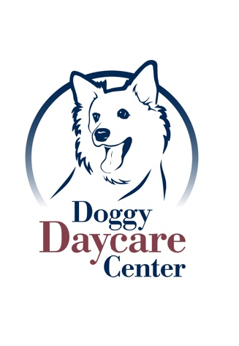
Orrville Pet Spa & Resort
Doggy Daycare Center
1669 N. Main St.
Orrville, Ohio 44667
(330) 683-3335 1-866-406-OPSR

DAYCARE POLICY FORM

All dogs must be in good health. If your dog is coughing, has diarrhea, or is displaying any sign of illness, please notify us prior to bringing your dog to daycare. Along with their vaccines we also require your pet to be on flea, tick, and heartworm prevention all year long. Daycare is a playground for dogs. Just like children, it is a place where they get to have lots of fun, but just like a child they can also get scrapes and scratches. Minimizing risks is part of our job as professional pet care providers, however, there is an inherent risk in all off-leash dog play. We will not be responsible for injuries resulting from play.

Spay/Neuter Policies: Any dog over the age of 6 months must be spayed/neutered to participate in group play. If arrangements need to be made for your dog until his/her spay/neuter date please see a daycare receptionist to discuss other available options under the following conditions; they are NOT excessively humping, they are NOT showing dominant behaviors or they are NOT creating an unsafe play environment.

Coughing Policies: Our policy requires the Bordetella Vaccine for ALL dogs to be given at least 72 hours prior to Doggy Daycare. This is for the protection of your pet as well as all our other guests. Even with this protection of vaccination, there is no 100% guarantee that disease can be prevented. If we hear your dog coughing while it is here we will notify you. We will isolate and monitor your dog for the remainder of the day. Due to the health of our other guests we cannot accept them at our Orrville Pet Spa Facility. Please contact us if your dog has been diagnosed with kennel cough or has been coughing.

