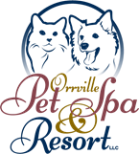
CUSTOMIZE YOUR DOG’S VACATION
Client’s Name: ____________________________________
Pet’s Name: ______________________________________

TREAT OPTIONS
___ Beggin’ Eggs, & Snausages $4.00 – A serving of scrambled eggs along with a side of one Beggin’ strip and Snausages delivered to your dog’s accommodations by room service.
___ K-9 Krazy Kong $3.00 – A great way to keep your dog busy while indoors. We stuff the Kong with peanut butter and give it to your dog for a nice treat. This activity is something your dog will enjoy both playing with and eating.
___ Gourmet Cookie $1.00 – A homemade, delicious cookie that makes for the perfect treat for your pet after potty walks.
___ Doggy Dessert $4.00 – A nutritious frozen peanut butter and yogurt cupcake delivered to your dog by room service.

