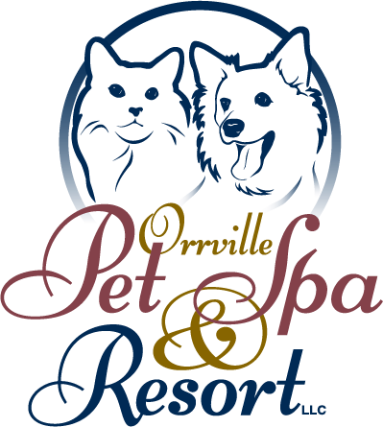
Orrville Pet Spa & Resort, LLC
1669 N. Main St.
Orrville, OH 44667
(330) 683-3335 / 1-866-406-OPSR
Fax: (330) 683-3345
offine@orrvillepetspa.com
POLICIES AND PROCEDURES

REQUIREMENTS FOR LODGING, STYLING AND DAYCARE

DOGS – Prior to arrival your dog must be current on Rabies, DHLPP, and a Bordetella within the last year. Canine Influenza is strongly recommended.

CATS – Prior to arrival your cat must be current on Rabies, FVRCP, and Feline Leukemia vaccines.

HOURS OF OPERATION:

LODGING:
7:00 am – 4:00pm Monday – Friday (Check-in no later than 3:00 pm)
7:00 am – 12:00 pm Saturday (Check-in no later than 11:00 am)
5:00 pm – 6:00 pm Sunday – All discharges must be scheduled and pre-paid at time of drop-off

DAYCARE:
7:00 am – 6:00 pm Monday – Friday (Early Check-in 6:30-7:00 am with additional fee)

The front office is closed on holidays for drop-off and pick-up.

You will be charged per day, beginning with the day you drop off. If you pick up by 12:00 pm Monday – Saturday, there will be no charge for that day. After 12:00 pm a full day’s rate will be accessed. This includes Sunday due to no morning pick-ups.

Reservations are required.

For your convenience, you may schedule appointments with the Orrville Veterinary Clinic, Inc. during your pet’s visit. An estimate can be provided upon request.

Singles or doubles can be reserved based upon availability. Specific rooms can be requested, but placement may be changed at any time during your pet’s stay at discretion of management.

Dogs in the same family that cannot behave appropriately together will be separated and charged full rate for each dog. These behaviors will be determined at the discretion of the management.

Covered accommodations are available. Any dogs that tend to climb or jump will be places in these rooms.

In the rare instance it is necessary to hospitalize your pet, care will continue at the Orrville Veterinary Clinic Inc. until he/she can safely return to lodging. Transportation can be arranged to your own veterinarian for treatment if desired.
Diarrhea is common among dogs, while boarding, due to stress. We will administer an anti-diarrhea medicine (Endosorb and/or FortiFlora) when we see a change in his/her stool. A one-time fee of $8.50 will be charged when medication is administered. Should the problem persist for more than 24 hours, we will be in contact for further treatment options.

You may bring your own food, bedding, and toys. We will provide a clean, comfortable fleece for your pet. Purina EN Sensitive Stomach food will be fed to your pet if your own food is not provided. We are not responsible for special items left at the facility. All items should be labeled to insure their return, but due to shifting of items for cleaning, we cannot always guarantee their return. Please do not bring anything to the facility that is irreplaceable.

We require that each owner maintain control of their animal while at our facility. Whether on a leash, locked retractable leash, or individually carrying your pet, it is important to have your dog under control at all times.

To participate in our Daycare program, all dogs must be approved, spayed or neutered, and current on vaccinations. Approval will be based on compatibility and at the discretion of the Daycare attendants.

Payment is required when services are rendered. Sunday discharges must be scheduled and pre-paid. We accept cash, personal checks, Visa, MasterCard, or Discover.

CANCELLATION NOTICE: For lodging, 24-hour notice is required, or the cost of one days stay in the room reserved will be charged. For grooming, 24-hour notice is required, or the cost of the groom will be charged.

NO SHOW POLICY: for lodging, the cost of the room reserved will be charged for all no-shows. For grooming, the cost of the groom will be charged.

RETURNED CHECK POLICIY: There is a $25.00 fee for all returned checks.

LATE FEE: An $11 late fee will be charged if you are late 5 minutes or more. After 30 minutes, your pet will be fed, walked and tucked in for the night. Late fees are assessed, and lodging rates apply.

Upon admission for services, your signature on Boarding Medical Release form acknowledges your awareness and acceptance of our policies. Thank you for your trust in allowing us to care for your pet.

Our mission at the Orrville Pet Spa and Resort, LLC is to provide premium care for your pet and create a home environment, giving you confidence that your pet is comfortable and well-cared for while you are away from home.

